**Image Capturing using Blink Detection**

*Abstract –*

Inspired by 'The Google Glass', this paper shows the method of capturing an image through a camera and triggering the same via eye blinks. This paper focuses of various methods that can be used to detect eye blinks and a comparative study of those methods. Also, it shows how to tackle various problems faced during the implementation of this application. Other components used for the working of the entire process are also listed and the functions have been described briefly. A flowchart of the entire process has been given to understand the process in a better way. Disabled people often are not able to enjoy life’s joys to the fullest. This project will help in aiding the disabled and providing a tool for them so that they can capture the world through their eyes. The future scope of this project has also been discussed.

*Introduction –*

This paper is a technical representation of our project, where we plan to capture an image of the real world with the help of an eye blink detection mechanism. Using one of the various techniques that we have studied, a signal is continuously passed to the microcontroller which analyses the signals and detects a blink. It occurs when the microcontroller senses a considerable change in the voltage value of the signal. The microcontroller then triggers an event which subsumes the sending of a signal to the camera. The camera now captures an image and sends it to a wireless bluetooth module, which is responsible for sending this image to the smartphone. Through this project, we look to aid the disabled & provide spying devices for detectives.

The purpose of this paper is to put forward a technique to capture an image using eye blink detection. The outline of the paper is as follows. In Section II, we explore the different methods for eye blink detection and determine their effectiveness through a comparative study. Having chosen the appropriate technique, we proceed to Section III, where a brief idea is given about the analysis of the signal by the microcontroller. Section IV emphasizes on the role of the Bluetooth module and the image processed by the smartphone. Conclusion and future remarks are described in Section V.

*Methods of Eye Blink detection –*

The first step is to detect an eye blink. This can be done using various methods namely –

1. Image Processing
2. Electrooculogram
3. Infrared technology

After describing each process in detail, we do a comparative study to find out which process is better based on the facts. The processes are described as follows -

*Image Processing –*

There are several ways that can be employed to perform eye blink detection using Image Processing. One of them is using the Haar Cascade Classifier. This technique has the following major steps:

1. Frame Capturing
2. Face Detection
3. Eye Detection
4. Eye Tracking
5. Eye Blink Detection

The first step in this process is the intialization where a video of the individual’s face is taken and correspondingly, a process Frame method is used to create frames from this captured video. The resultant colored frames are converted to gray scale by eliminating the component of luminance. Next, for face detection we use the Haar classifier which detects an object on the basis of a facial feature. The feature is detected if the classifier is regionalizing a particular area which has the highest probability of containing the sensed feature. Moving forward, the classifier detects the face and marks it with a colored rectangle which is later useful to approximate an axis for eye detection.

The detection of the eyes involves training the Haar classifiers. Once the face is detected, the AdaBoost and Haar feature algorithms train the classifier with the help of two sets of images. The first one contains the image scene, whereas the second does not contain the object at all. Consequently, having trained the Cascade classifer, the eyes are detected along the axis of the face recognition rectangle and another colored rectangle is formed bordering the eyes, showing that the eyes have been detected successfully.

Eye tracking relates to extracting features, parts of the eye in order to determine their movement. The two parts that are most important in this method are – the corneal reflection and pupil-center. With the backing of an accurate location of these features and the mathematical trignometric calculations involved, the point of regard for a pair of eyes can be found. The data obtained at the end of this procedure must be used in a sensible way because eye movements can either be voluntary or involuntary and experimental results must be evaluated accordingly. Finally, coming to the crux of the matter at hand, eye blink detection is performed using the frames that have been detected earlier. With the help of these frames, the status of the eye can be determined – whether it is open or closed. Applying binarization to frames, thresholding is performed. In binary frames, 0 represents the black color and 1 represents the white color for each pixel. To check if the eye is blinking, the length and width of the portion below the eyebrows is determined. Keeping a count on the number of gray and black points, if the number black points detected are greater than a predetermined number, the eye is closed else it is open.

The eye blink detection mechanism in this technique is subject to lighting conditions as well as the distance between the detector and the eye. If the distance is long, the process of recognition is extremely difficult. The accuracy differs depending on the lighting of the environment – natural or artificial. A significant takeaway from the IP technique is that the detection efficiency can be improved by applying the Medium Blur Filter on the binary frames. The filter aids in noise detection which is a typical pre-processing method to improve accuracy of blink detection.

*Electrooculogram –*

Another method for eye blink detection is using Electrooculogram. Eye blinks can be classified into 3 types – One is a spontaneous eye blink which occurs frequently, second is a reflexive eye blink which is evoked by an external stimulus and the last one is a voluntary eye blink which is caused by intentional eye closing. An eye blink generates electrical activity in the vertical and horizontal EOG. These can be represented by XY-Plane graphs with Amplitude VS Time respectively. These graphs are different for all the three types of blinks. Electrooculogram method uses these signals which are generated, identify its amplitude and determine the type of blink. After it determines the type of blink it takes the appropriate action.

To understand the working of detection of an eye blink using electrooculogram, let us first gain knowledge about the method used to capture the signals. Electrodes are the best equipment to measure the smallest of electrical activities. Four electrodes are placed on the upper, lower, left and right side of each eye. The reference electrode is placed at mastoid and the ground electrode is placed at frontal lobe. The vertical and horizontal signal are calculated by subtracting lower part signal from upper part signal and non-dominant signal from dominant signal respectively. The graphs of the electric signals detected by the electrodes for all the three different eye blinks can be illustrated as -

Here, we can see that the amplitude is different for different types of eye blinks. For all the vertical graphs, we can see that s2 has a greater value than s1 while in the case of horizontal graphs, it is not the same. Referring to the Vertical EOG’s, Double blinks and normal blinks have almost the same amplitude for s1 and different for s2. Vertical EOG of Wink has relatively lower amplitudethan the rest.

For detecting voluntary eye blinks which can trigger the system, we can set a threshold value for the Amplitude axis in the Vertical EOG so that whenever the electric signal’s amplitude goes beyond the threshold value, the system considers it as a voluntary blink and it triggers an event. In this way, the eye-blink detection mechanism works using an Electrooculogram.

Though the mechanism seems reliable, there are many disadvantages of this system as well. First, sometimes the event is triggered unvoluntarily since the sensors sometimes pick up faulty signals. Second, the entire equipment of Electrooculogram covers all the space and is not user-friendly hence no space is left for other components in the setup. Third, the equipments required are very costly and cannot be replaced easily. Hence, this method is not a completely efficient method for eye-blink detection.

*Infrared technology –*

One more method which can help in registering or detecting an eye blink is using Infrared technology. Here, the components used are IR LED’s and IR detectors. These components are placed at towards the sides of the glass frame. The peak transmission wavelength of the Infrared LED is around 880 µm, which is also the frequency of maximal sensitivity for the matching phototransistor. The LED and detector components are positioned at the nasal and temporal aspects of one’s eye, causing the infrared beam to pass horizontally across the central portion of the palpebral fissure, anterior to the corneal surface. The beam remains unbroken when the eye is open, but is interrupted by the eyelashes and/or lid tissue when the upper lid descends, a drop in output voltage is caused in the IR detector signal. The microcontroller is continuously in contact with the IR detector. To understand it in a better way let us refer to the diagram.

Let us understand the process again in simpler words. The beam that comes out from the IR transmitter passes just across the front of the eyes and on the other end of the rim there is an IR detector. Until IR beams are detected by the IR detector, it does not register a blink. When the user blinks i.e. brings his upper eye lids down, the IR beam is interfered by the eye lids or the upper skin and the IR detector does not detect any signal. This causes the IR detector to drop its output voltage. Also, a blink is registered at the microcontroller under these circumstances. In this way, an IR based blink detection circuit works.

The disadvantages of this method are that there are various fluctuations in the wavelength of IR beams, so when it exceeds a certain value the IR beams are detrimental to the user’s eyes. Also, the circuit here is very delicate and needs to be handled with care because the IR LED’s and Detectors are set at a specific angle, which when altered can damage the results.

*Comparative Study –*

After going through the disadvantages and the advantages of all the methods an eye blink can be detected to trigger an event, we choose the IR method of detecting the eye blink because of its advantages that far outweigh its disadvantages.

The advantages of using IR for blink detection are as follows –

1. It is very user friendly and cost effective compared to other methods.
2. The final product looks very simple and nor complicated for users. Also, it is light weight.
3. This method gives greater accuracy than any other method used for blink detection.
4. It does not involve large hardware components which make the product heavier.
5. Adding to this, the method or hardware technology used to detect the eye blink should be able to pass a signal to the microcontroller easily and relinquish its control to another component, which can be easily implemented in this case.

Hence, based on these advantages, the Infrared based eye blink detection system seemed to be more feasible and reliable and hence, we choose this method to detect the user’s eye blink.

There are some problems of using this technology as well. One of the problems, which we will face while implementing this method is to differentiate between voluntary and involuntary blinks. We successfully found out a way to differentiate between these different types of blinks so that the event is not triggered whenever the user blinks involuntarily or in simpler words, because of natural blinks. We set a condition which states that if the user blinks twice in the time range of 2 seconds, the event will be triggered. Another condition which we can use is if the user blinks a single eye and does not blink the other one, the event will be triggered. Any of these conditions can be set and implemented.

This will make the entire process more effective and less complicated, so that any user can understand the process. After the eye blink process, the control goes to other components in the system.

Let us understand the entire process by referring to a block diagram –

Eye blink detection using Infrared tech

Microcontroller

Camera

Bluetooth module

Image transferred to Smartphone

Here, we can clearly understand the entire process of this application. The functions of different components are given below.

*Microcontroller –*

The Infrared LED emitter and detector continuously pass its values to the microcontroller. The microcontroller processes these values and detects whether the user is trying to trigger the event. In this case, the user will trigger the event by blinking twice in the time range of two seconds. The microprocessor keeps a track of blinks the Infrared LED setup helps it to register. If it detects more than one blink in 2 seconds, it sends a signal to the camera and passes the control from infrared LED to the camera.

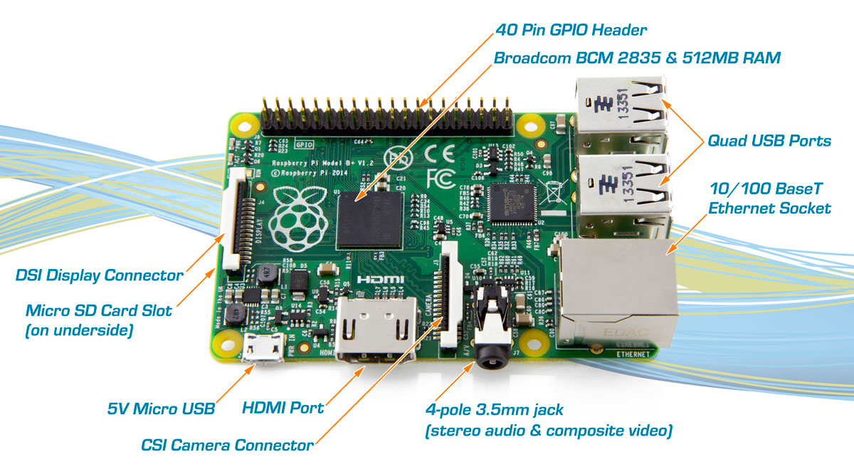

*Camera –*

When the microcontroller sends a signal to the camera, the camera captures an image using its module and makes this image ready for transferring it to the smartphone via Bluetooth. The camera module is connected to the microcontroller such as Arduino to automatically control the camera. The microcontroller is connected to the camera via a diode and a shutter switch cable. When the microcontroller passes a LOW voltage signal to the camera, the camera module activates and when the microcontroller passes a HIGH voltage signal to the camera, the diode becomes reverse biased and prevents the electricity flowing into the camera to avoid damaging thee camera module. In this way, a microcontroller and a camera work. The camera which is suited for this use is the LinkSprite JPEG Colour Camera TTL Interface, which looks like this –

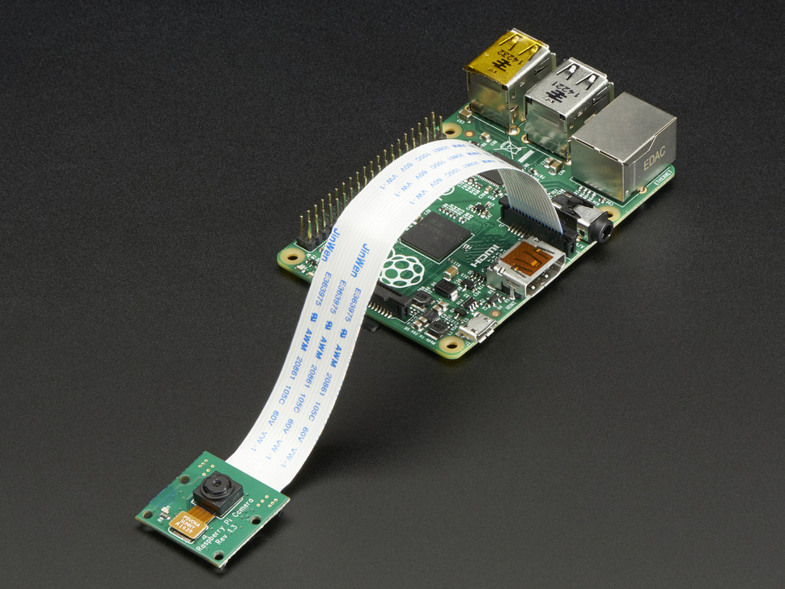

*Bluetooth dongle –*

Bluetooth is a wireless technology which helps in transferring files from one device to other using radio waves. It operates at the frequency of around 2.4 GHz. The transfer of data takes places only over short distances. After the camera has captured the image it transfers the image to the Bluetooth module and makes it ready to transfer. The microcontroller then transfers the control to the Bluetooth module. The Bluetooth module has to be paired with the smartphone for transferring the images without any glitch. It then transfers the image wirelessly to the android device. The Bluetooth needs to be connected to the camera and the microcontroller at the same time. The Raspberry Pi Bluetooth dongle looks as –

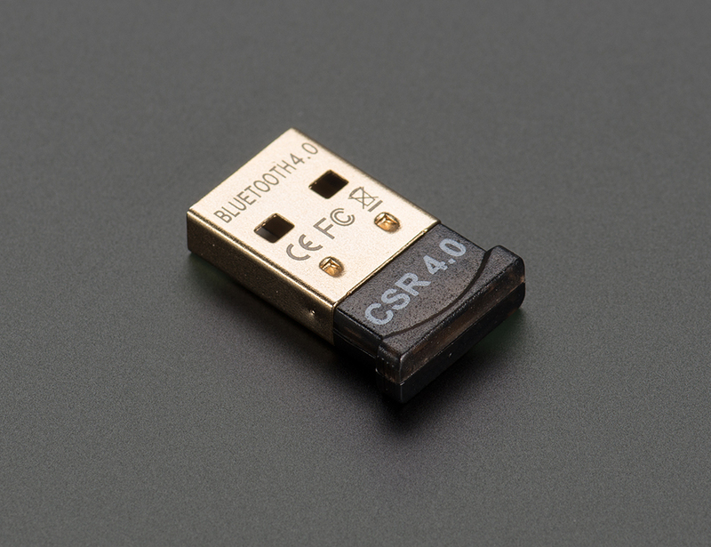

In this way, these components function to give optimum results for the application. This application will help the disabled and paralyzed people to be able to gain the joys of life. They will be able to capture the world through a camera without restraining due to any of their disability.

*Future Scope –*

1. The triggering event can be set as the user wants it. For instance – If a user wants the event to trigger when he blinks his left eye twice, he should be able to set it.
2. This device can be used as a spy equipment, which can help them to capture certain images without losing eyes on their target.
3. Also, cops can use this device to scan people on the go and prevent harmful attacks by people carrying harmful weapons illegally. For this purpose, the glasses in the goggles can be converted to a LCD screen and Image Processing techniques can be used to detect any substance they want to.
4. Adding to this, it can also be used for video recording purposes by students, professors and many other sections of the society.

*Conclusion –*

Image capturing using blink detection is a feasible project and it has a variety of components functioning inside it. There are various ways this project can be implemented. The most suitable way is using Infrared LED’s to detect the eye blinks. This project has a lot of future scope and it can prove to be very useful for the disabled people to gin life’s most precious joys.

*References –*